TASK 10: VALIDATION

Industrial Processes: The Contact Process
Score:

_________/36

Time allowed: 40 minutes
Name: _______________________________

Complete all questions in the space provided.

The following passage provides a summary of the Contact Process

The Contact Process is used in the manufacture of sulfuric acid. The process involved three main steps:

Step 1: Production of sulfur dioxide
This can be completed in one of two ways

Sulfur is burnt in excess oxygen (air)

$$S \left(s\right)+O_{2} \left(g\right)→SO_{2} (g)$$

Sulfide ores like pyrite are heated in air

$$4FeS_{2} \left(s\right)+11O_{2} \left(g\right)→2Fe_{2}O_{3} \left(s\right)+8SO_{2} (g)$$

Step 2: Conversion of sulfur dioxide into sulfur trioxide

This is a reversible exothermic reaction

$$2SO_{2}\left(g\right)+O_{2}\left(g\right)⇌2SO_{3}\left(g\right) ΔH=-196kJ/mol$$

See the flowchart for this stage below

400-450°C
2 atm
V₂O₅ catalyst
Sulfur trioxide
Sulfur dioxide
+ oxygen

Step 3: Converting sulfur trioxide to sulfuric acid

This stage is completed in two steps, this is done to avoid producing a sulfuric acid fog

Firstly, the sulfur trioxide is dissolved in existing sulfuric acid

$$H_{2}SO_{4} \left(l\right)+SO_{3} \left(g\right)→H_{2}S_{2}O_{7} (l)$$

The product, fuming sulfuric acid or oleum, is then safely reacted with water

$$H_{2}S_{2}O_{7} (l)+H_{2}O(l)→2H_{2}SO_{4}(l)$$

Question 1 7 marks

The Contact Process can be represented by the three equations below

$$S \left(s\right)+O_{2} \left(g\right)→SO_{2} (g)$$

$$2SO_{2}\left(g\right)+O_{2}\left(g\right)⇌2SO_{3}\left(g\right)$$

$$SO_{3}\left(g\right)+ H_{2}O\left(l\right)→ H_{2}SO_{4}(l)$$

(a) write an overall chemical equation for the Contact Process reactions above. (2 marks)

(b) calculate the mass of sulfuric acid that can be produced from 1.00 x 10³ L of oxygen gas at S.T.P assuming the process is only 98.0% efficient. Express your final answer to the correct number of significant figures. (5 marks)

Question 2 and 3 refer to the conversion of sulfur dioxide into trioxide in step 2.

$$2SO_{2}\left(g\right)+O_{2}\left(g\right)⇌2SO_{3}\left(g\right) ΔH=-196kJ/mol$$

Question 2 5 marks

The typical operating conditions for this step are described on page one of this task.

Using knowledge of reaction rates and Collision Theory, explain the effect of the high pressure stated above on the rates and theoretical yield of sulfur trioxide gas.

Questions 3 4 marks

State the effect of the following imposed changes on the equilibrium system above.

Imposed change | Effect on the rate of the forward reaction  (write increase, decrease or no change) | Effect on the yield of SO₃  (write increase, decrease or no change) | Effect on the value of K  (write increase, decrease or no change)
Temperature is increased to 600ºC

The partial pressure of SO₂ is increased

Volume of reaction vessel is increased |  |  | No change

Question 4 2 marks
Calculate the atom economy for the reaction:
$$4FeS_{2} \left(s\right)+11O_{2} \left(g\right)→2Fe_{2}O_{3} \left(s\right)+8SO_{2} (g)$$

where the desired product is sulfur dioxide. The relevant mathematical relationship is shown below.

Atom economy = total molar mass of atoms in desired product x 100
total molar mass of atoms in all reactants

Question 5 11 marks

A devout ‘Green’ chemist, after years of research, believed that he and his team of chemists had discovered a protein mixture to catalyse the reaction mentioned in Step 2. Apart from a faster rate of reaction, this biological catalyst would reduce heating needs and usage of non-renewable fossil fuels for heating.

A chemical species, X, found in the protein mixture has the structure shown below.

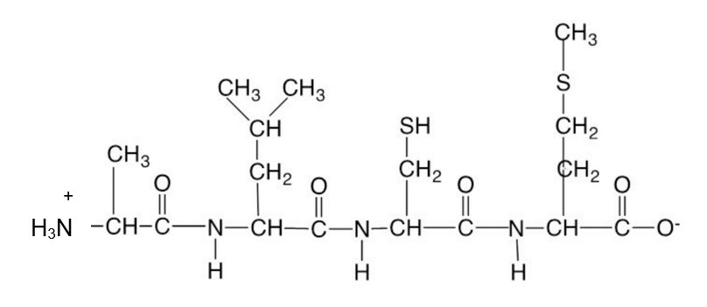

(a) Identify the amino acids in X. Use symbols to write the correct sequence of amino acids in X from left to right (e.g. Ala – Arg – Asn etc.) (2 marks)
_______________________________________________________________________________

For parts (b) and (c), circle one option.

(b) The aqueous solution containing X is most likely to have a pH of
(1 mark)
- 0
(ii) 2
(iii) 7
(iv) 12

(c) In an aqueous solution of X, what would be the strongest form of interaction between X and water molecules? (1 mark)

- Hydrogen bonds.
(ii) Dipole-dipole interaction.
(iii) Ion-dipole interaction.
(iv) Ionic attraction

(d) Another chemical species found in the catalyst mixture is the α-amino acid valine. Draw the structure of valine in a solution having a pH of 10. (1 mark)

(e) Use the Chemistry Data Sheet provided to determine the most dominant interaction that may be formed between adjacent - R groups of the two polypeptides below. The interactions of interest are shown by the numbers 1, 2 and 3 in the diagram below.
(3 marks)

Ser – Cys – Met – Thr
⏐ ⏐ ⏐
R R R

1 2 3

R R R
⏐ ⏐ ⏐
Gly – Cys - Val – Ser

Name of dominant interaction shown by number 1: ___________________

Name of dominant interaction shown by number 2: ___________________

Name of dominant interaction shown by number 3: ___________________

After a series of repeated trials, a team member advised the ‘Green’ chemist that the biological catalyst may not be suitable. This advice was based on the photographs below showing the same protein structure at 35ºC and at 42ºC.

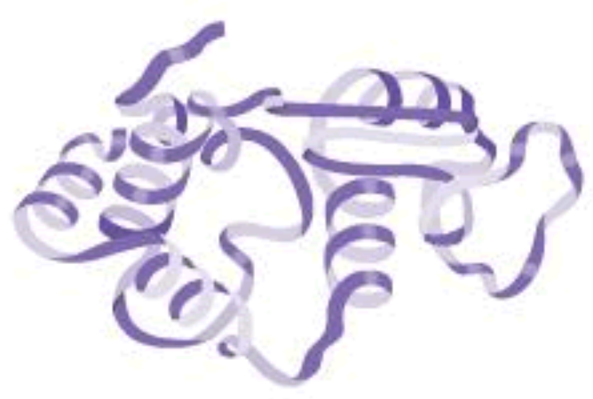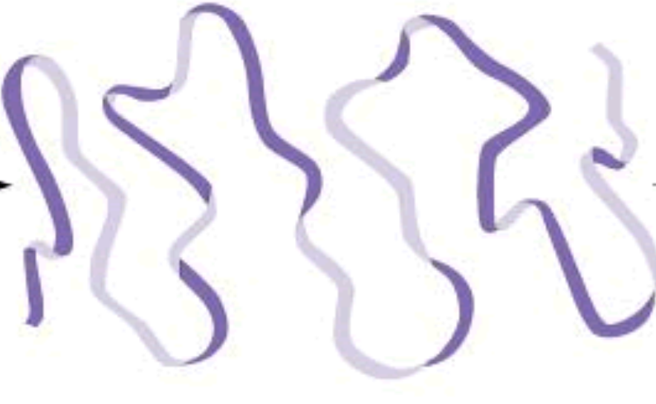

At 35ºC At 42ºC

(f) With reference to your knowledge of protein structures, explain what has happened to the protein in the images above. (3 marks)

The following question refers to the production of oleum in Step 3.

Question 7 7 marks

The chemical equation for the process is
$$H_{2}SO_{4} \left(l\right)+SO_{3} \left(g\right)→H_{2}S_{2}O_{7} (l)$$

In an efficiency trial, 0.40 g of sulfuric acid is allowed to react with 100.0 mL of sulfur trioxide at 200.0ºC and 100.0 kPa. Determine

(a) the limiting reactant. (3 marks)

(b) In a separate trial, 3.00g of sulfuric acid was reacted with sulfur trioxide. Given that the actual mass of 3.00g of oleum was produced, calculate the percentage yield of this trial.
(4 marks)

_{END OF PAPER}

